UNITED STATES
SECURITIES AND EXCHANGE COMMISSION
Washington, D.C. 20549
FORM 8-K
CURRENT REPORT PURSUANT TO SECTION 13 OR 15(d) OF
THE SECURITIES EXCHANGE ACT OF 1934
July 30, 2026
Date of Report (Date of earliest event reported)
QUAKER CHEMICAL CORPORATION
(Exact name of registrant as specified in its charter)
Commission File Number 001-12019
Pennsylvania |  |  | 23-0993790
(State or other jurisdiction of  incorporation) |  |  | (I.R.S. Employer  Identification No.)
901 E. Hector Street
Conshohocken, Pennsylvania 19428
(Address of principal executive offices)
(Zip Code)
(610) 832-4000
(Registrant’s telephone number, including area code)
Not Applicable
(Former name or former address, if changed since last report)
Check the appropriate box below if the Form 8-K filing is intended to simultaneously satisfy the filing obligation of the registrant under any of the following provisions:
o |  |  | Written communications pursuant to Rule 425 under the Securities Act (17 CFR 230.425)
o |  |  | Soliciting material pursuant to Rule 14a-12 under the Exchange Act (17 CFR 240.14a-12)
o |  |  | Pre-commencement communications pursuant to Rule 14d-2(b) under the Exchange Act (17 CFR 240.14d-2(b))
o |  |  | Pre-commencement communications pursuant to Rule 13e-4(c) under the Exchange Act (17 CFR 240.13e-4(c))
Securities registered pursuant to Section 12(b) of the Act:
Title of each class |  |  |  |  |  | Trading Symbol(s) |  |  |  |  |  | Name of each exchange on which registered
Common Stock, $1 par value |  |  |  |  |  | KWR |  |  |  |  |  | New York Stock Exchange
Indicate by check mark whether the registrant is an emerging growth company as defined in Rule 405 of the Securities Act of 1933 (§230.405 of this chapter) or Rule 12b-2 of the Securities Exchange Act of 1934 (§240.12b-2 of this chapter).
Emerging growth company o
If an emerging growth company, indicate by check mark if the registrant has elected not to use the extended transition period for complying with any new or revised financial accounting standards provided pursuant to Section 13(a) of the Exchange Act. o

INFORMATION TO BE INCLUDED IN THE REPORT
Item 2.02. Results of Operations and Financial Condition.
On July 30, 2026, Quaker Chemical Corporation announced its results of operations for the second quarter ended June 30, 2026 in a press release, the text of which is included as Exhibit 99.1 hereto. Supplemental information related to the same period is also included as Exhibit 99.2 hereto.

Item 9.01. Financial Statements and Exhibits.
The following exhibits are included as part of this report:
Exhibit No. |  |  |  |  |  | Description
99.1 |  |  |  |  |  | Press Release of Quaker Chemical Corporation dated July 30, 2026 (furnished herewith).
99.2 |  |  |  |  |  | Supplemental Information related to the second quarter ended June 30, 2026 (furnished herewith).
104 |  |  |  |  |  | Cover Page Interactive Data File (embedded within the Inline XBRL document).

2

SIGNATURE
Pursuant to the requirements of the Securities Exchange Act of 1934, the Registrant has duly caused this report to be signed on its behalf by the undersigned hereunto duly authorized.
 |  |  | QUAKER CHEMICAL CORPORATION
Date: July 30, 2026 |  |  | By: |  |  | /s/ Thomas Coler
 |  |  |  |  |  | Thomas Coler
 |  |  |  |  |  | Executive Vice President, Chief Financial Officer

Exhibit 99.1
3
NEWS  Contact: John Dalhoff  Director, Investor Relations  investor@quakerhoughton.com  T. 1.610.684.7822 |  |  | 
For Release: Immediate

QUAKER HOUGHTON ANNOUNCES SECOND QUARTER 2026 RESULTS

•Q2’26 net sales of $532.6 million, an increase of 10% Y/Y
•Q2’26 net income of $26.8 million and earnings per diluted share of $1.55
•Sales volumes increased 7% Y/Y primarily driven by new business wins across all segments
•Q2’26 non-GAAP net income of $37.9 million and non-GAAP earnings per diluted share of $2.19, a 28% increase Y/Y
•Delivered Q2’26 adjusted EBITDA of $85.2 million, a 13% increase Y/Y
•Increased quarterly dividend by approximately 4.3% and repurchased $24.2 million of shares in Q2’26; announced new $250 million stock repurchase program

July 30, 2026
CONSHOHOCKEN, PA – Quaker Houghton (“the Company”) (NYSE: KWR), the global leader in industrial process fluids, announced its second quarter 2026 results today.
 |  |  | Three Months Ended  June 30, |  |  |  |  |  |  |  |  |  |  |  | Six Months Ended  June 30,
($ in thousands, except per share data) |  |  | 2026 |  |  |  |  |  | 2025 |  |  |  |  |  | 2026 |  |  |  |  |  | 2025
Net sales |  |  | $ | 532,550 |  |  |  |  | $ | 483,400 |  |  |  |  | $ | 1,013,029 |  |  |  |  | $ | 926,314
Net income (loss) attributable to Quaker Chemical Corporation |  |  | 26,835 |  |  |  |  |  | (66,580) |  |  |  |  |  | 46,504 |  |  |  |  |  | (53,658)
Net income (loss) attributable to Quaker Chemical Corporation common shareholders – diluted |  |  | 1.55 |  |  |  |  |  | (3.78) |  |  |  |  |  | 2.68 |  |  |  |  |  | (3.04)
Non-GAAP net income * |  |  | 37,903 |  |  |  |  |  | 30,000 |  |  |  |  |  | 66,277 |  |  |  |  |  | 58,029
Non-GAAP earnings per diluted share * |  |  | 2.19 |  |  |  |  |  | 1.71 |  |  |  |  |  | 3.82 |  |  |  |  |  | 3.29
Adjusted EBITDA * |  |  | 85,166 |  |  |  |  |  | 75,479 |  |  |  |  |  | 157,696 |  |  |  |  |  | 144,527
*Refer to the Non-GAAP Measures and Reconciliations section below for additional information

Second Quarter 2026 Consolidated Results
Net sales in the second quarter of 2026 were $532.6 million, an increase of 10% compared to $483.4 million in the second quarter of 2025. This increase was primarily driven by an increase in sales volumes of 7%, a favorable impact from foreign currency translation of 2%, and an improvement in selling price and product mix of 1%. The increase in sales volumes compared to the prior year was primarily the result of net new business wins across all segments.
The Company reported net income in the second quarter of 2026 of $26.8 million, or $1.55 per diluted share, compared to a net loss of $66.6 million, or $3.78 loss per diluted share, in the second quarter of 2025. Excluding non-recurring and non-core items in each period, the Company’s non-GAAP net income and non-GAAP earnings per diluted share were $37.9 million and $2.19, respectively, in the second quarter of 2026 compared to $30.0 million and $1.71, respectively, in the second quarter of 2025. The Company generated adjusted EBITDA of $85.2 million in the second quarter of 2026, an increase of approximately 13% compared to $75.5 million in the second quarter of 2025, primarily driven by the increase in net sales, partially offset by higher SG&A expenses. See the Non-GAAP Measures and Reconciliations section below for additional information.

Joe Berquist, Chief Executive Officer and President, commented, “We achieved our fourth consecutive quarter of year-over-year profitability growth in Q2 2026, resulting in record adjusted EBITDA. Net sales increased 10% against prior year, driven by strong share gains and pricing during a period of significant raw material inflation. Volume growth reflected new business wins across all regions that exceeded the high end of our target range, while underlying markets were flat to slightly positive. Demand has remained steady against the backdrop of the conflict in the Strait of Hormuz, and we have observed selective areas of market growth. We experienced modest pre-buy activity from our customers early in the period in reaction to the conflict, with normal seasonal patterns returning by the end of the quarter. I’m proud of our team’s ability to maintain reliable supply to our customers despite heightened volatility.

1
Looking ahead, we expect stable demand trends entering the third quarter with flat to slightly positive end markets throughout the remainder of the year. We anticipate gross margin percentage to stabilize in the third quarter in the range of second quarter gross margins as we work through the timing of raw material cost inflation, inventory movements and price recovery actions. Our pricing and cost initiatives have kept us on track to exit the year within our target gross margin range. We anticipate meaningful revenue and adjusted EBITDA growth in 2026 supported by continued share gains, disciplined cost management, and the resilience of our global network.”

Second Quarter 2026 Segment Results
The Company’s second quarter of 2026 operating performance for each of its three reportable segments: (i) Americas; (ii) EMEA; and (iii) Asia/Pacific, is further described below.
 |  |  | Three Months Ended  June 30, |  |  |  |  |  |  |  |  |  |  |  | Six Months Ended  June 30,
 |  |  | 2026 |  |  |  |  |  | 2025 |  |  |  |  |  | 2026 |  |  |  |  |  | 2025
Net Sales *
Americas |  |  | $ | 236,513 |  |  |  |  | $ | 221,062 |  |  |  |  | $ | 450,241 |  |  |  |  | $ | 434,773
EMEA |  |  | 158,436 |  |  |  |  |  | 139,923 |  |  |  |  |  | 300,519 |  |  |  |  |  | 269,201
Asia/Pacific |  |  | 137,601 |  |  |  |  |  | 122,415 |  |  |  |  |  | 262,269 |  |  |  |  |  | 222,340
Total net sales |  |  | $ | 532,550 |  |  |  |  | $ | 483,400 |  |  |  |  | $ | 1,013,029 |  |  |  |  | $ | 926,314
Segment operating earnings *
Americas |  |  | $ | 57,241 |  |  |  |  | $ | 58,976 |  |  |  |  | $ | 111,188 |  |  |  |  | $ | 117,438
EMEA |  |  | 32,740 |  |  |  |  |  | 24,995 |  |  |  |  |  | 58,301 |  |  |  |  |  | 48,388
Asia/Pacific |  |  | 36,559 |  |  |  |  |  | 28,715 |  |  |  |  |  | 70,835 |  |  |  |  |  | 54,645
Total segment operating earnings |  |  | $ | 126,540 |  |  |  |  | $ | 112,686 |  |  |  |  | $ | 240,324 |  |  |  |  | $ | 220,471
*Refer to the Segment Measures and Reconciliations section below for additional information
The following table summarizes the sales variances by reportable segment and consolidated operations in the second quarter of 2026 compared to the second quarter of 2025:
 |  |  | Sales volumes |  |  |  |  |  | Selling price & product mix |  |  |  |  |  | Foreign currency |  |  |  |  |  | Acquisition & other |  |  |  |  |  | Total
Americas |  |  | 4 |  | % |  |  |  | 1 |  | % |  |  |  | 2 |  | % |  |  |  | — |  | % |  |  |  | 7 |  | %
EMEA |  |  | 7 |  | % |  |  |  | 4 |  | % |  |  |  | 2 |  | % |  |  |  | — |  | % |  |  |  | 13 |  | %
Asia/Pacific |  |  | 10 |  | % |  |  |  | 1 |  | % |  |  |  | 1 |  | % |  |  |  | — |  | % |  |  |  | 12 |  | %
Consolidated |  |  | 7 |  | % |  |  |  | 1 |  | % |  |  |  | 2 |  | % |  |  |  | — |  | % |  |  |  | 10 |  | %
Net sales in the Asia/Pacific segment increased 12% in the second quarter of 2026 compared to the same period in 2025, as a result of an increase in sales volumes, an increase in selling price and product mix, and a favorable impact of foreign currency translation. Net sales in the EMEA segment increased 13% in the second quarter of 2026 compared to the same period in 2025, due to an increase in sales volumes, an increase in selling price and product mix, and a favorable impact of foreign currency translation. Net sales in the Americas segment in the second quarter of 2026 increased 7% compared to the same period in 2025, due to an increase in sales volumes, an increase in selling price and product mix, and a favorable impact of foreign currency translation.
Underlying end market activity in the second quarter of 2026 was similar to prior year levels, while strong new business wins across all segments led to year-over-year volume growth compared to the prior year quarter. The increase in selling price and product mix in the second quarter of 2026 compared to the same period in 2025 reflects pricing actions taken to offset higher raw material costs, as well as changes in the mix of products and services, and the impact of our index-based customer contracts.
Consolidated net sales increased approximately 11% compared to the first quarter of 2026, driven by an increase in sales volumes and an increase in selling price and product mix across all segments.
Segment operating earnings increased in the EMEA and Asia/Pacific segments in the second quarter of 2026 compared to the prior year period primarily due to the improvement in net sales and an improvement in segment operating margins, partially offset by an increase in SG&A expenses. Segment operating earnings decreased in the Americas segment in the second quarter of 2026 compared to the prior year due to higher raw material costs and SG&A expenses, partially offset by an increase in net sales. Segment operating earnings increased in all three segments in the second quarter of 2026 compared to the first quarter of 2026, primarily driven by an increase in net sales in all three segments and improved operating margins in the EMEA segment, partially offset by a decrease in operating margins in the Asia/Pacific and Americas segments.

2
Cash Flow and Liquidity Highlights
Net cash provided by operating activities was $33.2 million for the six months ended June 30, 2026, compared to net cash provided by operating activities of $38.5 million for the same period in 2025. The Company’s decrease in operating cash flow year-over-year primarily reflects higher net cash outflows from working capital, partially offset by improved operating performance and lower outflows from restructuring activities.
As of June 30, 2026, the Company’s total gross debt was $876.1 million and its cash and cash equivalents was $155.1 million, which resulted in net debt of approximately $721.0 million. The Company’s net debt divided by its trailing twelve months adjusted EBITDA was approximately 2.3x.
In the second quarter of 2026, the Company announced a new share repurchase program authorizing the Company to repurchase up to an aggregate of $250 million of Quaker Chemical Corporation common stock, which replaced the 2024 Share Repurchase Plan and has no expiration date. In the second quarter of 2026, the Company repurchased 170,568 shares for approximately $24.2 million.

Non-GAAP Measures and Reconciliations
The information in this press release includes non-GAAP (unaudited) financial information that includes EBITDA, adjusted EBITDA, adjusted EBITDA margin, non-GAAP operating income, non-GAAP operating margin, non-GAAP gross profit, non-GAAP gross margin, taxes on income before equity in net income of associated companies – adjusted, non-GAAP net income and non-GAAP earnings per diluted share. The Company believes these non-GAAP financial measures provide meaningful supplemental information as they enhance a reader’s understanding of the financial performance of the Company, facilitate a comparison among fiscal periods, and exclude items that management believes are not indicative of future operating performance or considered core to the Company’s operations. Non-GAAP results are presented for supplemental informational purposes only and should not be considered a substitute for the financial information presented in accordance with GAAP. In addition, our definitions of EBITDA, adjusted EBITDA, adjusted EBITDA margin, non-GAAP operating income, non-GAAP operating margin, non-GAAP gross profit, non-GAAP gross margin, taxes on income before equity in net income of associated companies – adjusted, non-GAAP net income, and non-GAAP earnings per diluted share, as discussed and reconciled below to the most comparable GAAP measures, may not be comparable to similarly named measures reported by other companies.
The Company presents EBITDA, which is calculated as net income attributable to the Company before depreciation and amortization, interest expense, and taxes on income before equity in net income of associated companies. The Company also presents adjusted EBITDA, which is calculated as EBITDA plus or minus certain items that management believes are not indicative of future operating performance or considered core to the Company’s operations. In addition, the Company presents non-GAAP operating income, which is calculated as operating income plus or minus certain items that management believes are not indicative of future operating performance or considered core to the Company’s operations. The Company also presents non-GAAP gross profit, which is calculated as gross profit plus or minus certain items that management believes are not indicative of future operating performance or considered core to the Company’s operations. Additionally, the Company presents non-GAAP Adjusted EBITDA margin, non-GAAP operating margin, and non-GAAP gross margin, which are calculated as the percentage of adjusted EBITDA, non-GAAP operating income, and non-GAAP gross profit to consolidated net sales, respectively. The Company believes these non-GAAP measures provide transparent and useful information and are widely used by analysts, investors, and competitors in our industry, as well as by management in assessing the operating performance of the Company on a consistent basis.
Additionally, the Company presents non-GAAP net income and non-GAAP earnings per diluted share as additional performance measures. Non-GAAP net income is calculated as adjusted EBITDA, defined above, less depreciation and amortization, interest expense, and taxes on income before equity in net income of associated companies, in each case adjusted, as applicable, for any depreciation, amortization, interest or tax impacts resulting from the non-core items identified in the reconciliation of net income attributable to the Company to adjusted EBITDA. Non-GAAP earnings per diluted share is calculated as non-GAAP net income per diluted share as accounted for under the “two-class share method.” The Company believes that non-GAAP net income and non-GAAP earnings per diluted share provide transparent and useful information and are widely used by analysts, investors, and competitors in our industry as well as by management in assessing the performance of the Company on a consistent basis.
As it relates to future projections for the Company as well as other forward-looking information contained in this press release, the Company has not provided guidance for comparable GAAP measures or a quantitative reconciliation of forward-looking non-GAAP financial measures to the most directly comparable U.S. GAAP measure because it is unable to determine with reasonable certainty the ultimate outcome of certain significant items necessary to calculate such measures without unreasonable effort. These items include, but are not limited to, certain non-recurring or non-core items the Company may record that could materially impact net income. These items are uncertain, depend on various factors, and could have a material impact on the U.S. GAAP reported results for the guidance period.
3
The Company's reference to trailing twelve months adjusted EBITDA within this press release refers to the twelve-month period ended June 30, 2026 adjusted EBITDA of $312.4 million, which consists of (i) the six months ended June 30, 2026 adjusted EBITDA of $157.7 million, as presented in the non-GAAP reconciliations below, and (ii) the twelve months ended December 31, 2025 adjusted EBITDA of $299.2 million, as presented in the non-GAAP reconciliations included in the Company's fourth quarter and full year 2025 results press release dated February 23, 2026, less (iii) the six months ended June 30, 2025 adjusted EBITDA of $144.5 million, as presented in the non-GAAP reconciliations below.
Certain of the prior period non-GAAP financial measures presented in the following tables have been adjusted to conform with current period presentation. The following tables reconcile the Company’s non-GAAP financial measures (unaudited) to their most directly comparable GAAP (unaudited) financial measures (dollars in thousands unless otherwise noted, except per share amounts):

Non-GAAP Gross Profit and Margin Reconciliations |  |  | Three Months Ended  June 30, |  |  |  |  |  |  |  |  |  |  |  | Six Months Ended  June 30,
 |  |  | 2026 |  |  |  |  |  | 2025 |  |  |  |  |  | 2026 |  |  |  |  |  | 2025
Gross profit |  |  | $ | 189,204 |  |  |  |  | $ | 171,723 |  |  |  |  | $ | 365,939 |  |  |  |  | $ | 332,983
Acquisition-related step-up inventory amortization |  |  | — |  |  |  |  |  | 6,022 |  |  |  |  |  | — |  |  |  |  |  | 6,022
Gain on inventory and other adjustments |  |  | — |  |  |  |  |  | (3,604) |  |  |  |  |  | — |  |  |  |  |  | (3,604)
Non-GAAP gross profit |  |  | $ | 189,204 |  |  |  |  | $ | 174,141 |  |  |  |  | $ | 365,939 |  |  |  |  | $ | 335,401
Non-GAAP gross margin (%) |  |  | 35.5 |  | % |  |  |  | 36.0 |  | % |  |  |  | 36.1 |  | % |  |  |  | 36.2 |  | %

Non-GAAP Operating Income and Margin Reconciliations |  |  | Three Months Ended  June 30, |  |  |  |  |  |  |  |  |  |  |  | Six Months Ended  June 30,
 |  |  | 2026 |  |  |  |  |  | 2025 |  |  |  |  |  | 2026 |  |  |  |  |  | 2025
Operating income (loss) |  |  | $ | 40,603 |  |  |  |  | $ | (52,510) |  |  |  |  | $ | 74,192 |  |  |  |  | $ | (24,886)
Acquisition-related step-up inventory amortization |  |  | — |  |  |  |  |  | 6,022 |  |  |  |  |  | — |  |  |  |  |  | 6,022
Restructuring and related charges, net |  |  | 8,116 |  |  |  |  |  | 8,793 |  |  |  |  |  | 15,497 |  |  |  |  |  | 23,383
Acquisition-related expenses |  |  | 219 |  |  |  |  |  | 803 |  |  |  |  |  | 934 |  |  |  |  |  | 4,133
Gain on inventory and other adjustments |  |  | — |  |  |  |  |  | (3,927) |  |  |  |  |  | — |  |  |  |  |  | (3,927)
Business transformation costs |  |  | 4,113 |  |  |  |  |  | — |  |  |  |  |  | 5,772 |  |  |  |  |  | —
Impairment charges |  |  | — |  |  |  |  |  | 88,840 |  |  |  |  |  | — |  |  |  |  |  | 88,840
Duplicate headquarter lease costs |  |  | 564 |  |  |  |  |  | — |  |  |  |  |  | 886 |  |  |  |  |  | —
Acquisition-related depreciation and amortization |  |  | 1,586 |  |  |  |  |  | 1,681 |  |  |  |  |  | 3,194 |  |  |  |  |  | 1,681
Other charges |  |  | 86 |  |  |  |  |  | 939 |  |  |  |  |  | 161 |  |  |  |  |  | 1,165
Non-GAAP operating income |  |  | $ | 55,287 |  |  |  |  | $ | 50,641 |  |  |  |  | $ | 100,636 |  |  |  |  | $ | 96,411
Non-GAAP operating margin (%) |  |  | 10.4 |  | % |  |  |  | 10.5 |  | % |  |  |  | 9.9 |  | % |  |  |  | 10.4 |  | %
4
EBITDA, Adjusted EBITDA, Adjusted EBITDA Margin and Non-GAAP Net Income Reconciliations |  |  | Three Months Ended  June 30, |  |  |  |  |  |  |  |  |  |  |  | Six Months Ended  June 30,
 |  |  | 2026 |  |  |  |  |  | 2025 |  |  |  |  |  | 2026 |  |  |  |  |  | 2025
Net income (loss) attributable to Quaker Chemical Corporation |  |  | $ | 26,835 |  |  |  |  | $ | (66,580) |  |  |  |  | $ | 46,504 |  |  |  |  | $ | (53,658)
Depreciation and amortization (a) |  |  | 25,595 |  |  |  |  |  | 23,921 |  |  |  |  |  | 51,465 |  |  |  |  |  | 44,751
Interest expense |  |  | 9,873 |  |  |  |  |  | 12,779 |  |  |  |  |  | 19,752 |  |  |  |  |  | 22,324
Taxes on income before equity in net income of associated companies (b) |  |  | 11,172 |  |  |  |  |  | 5,472 |  |  |  |  |  | 18,317 |  |  |  |  |  | 13,014
EBITDA |  |  | 73,475 |  |  |  |  |  | (24,408) |  |  |  |  |  | 136,038 |  |  |  |  |  | 26,431
Equity income in a captive insurance company |  |  | (3,028) |  |  |  |  |  | (2,075) |  |  |  |  |  | (3,635) |  |  |  |  |  | (2,746)
Acquisition-related step-up inventory amortization |  |  | — |  |  |  |  |  | 6,022 |  |  |  |  |  | — |  |  |  |  |  | 6,022
Restructuring and related charges, net |  |  | 8,116 |  |  |  |  |  | 8,793 |  |  |  |  |  | 15,497 |  |  |  |  |  | 23,383
Acquisition-related expenses |  |  | 219 |  |  |  |  |  | 803 |  |  |  |  |  | 934 |  |  |  |  |  | 4,133
Gain on inventory and other adjustments |  |  | — |  |  |  |  |  | (3,927) |  |  |  |  |  | — |  |  |  |  |  | (3,927)
Business transformation costs |  |  | 4,113 |  |  |  |  |  | — |  |  |  |  |  | 5,772 |  |  |  |  |  | —
Pension and postretirement benefit costs, non-service components |  |  | 326 |  |  |  |  |  | 449 |  |  |  |  |  | 577 |  |  |  |  |  | 882
Impairment charges |  |  | — |  |  |  |  |  | 88,840 |  |  |  |  |  | — |  |  |  |  |  | 88,840
Product liability claim reimbursement |  |  | (1,000) |  |  |  |  |  | — |  |  |  |  |  | (1,000) |  |  |  |  |  | —
Currency conversion impacts of hyper-inflationary economies |  |  | 584 |  |  |  |  |  | 652 |  |  |  |  |  | 755 |  |  |  |  |  | 1,187
(Gain) loss on acquisition-related hedges |  |  | — |  |  |  |  |  | (592) |  |  |  |  |  | — |  |  |  |  |  | 1,351
Gain on sale of assets |  |  | — |  |  |  |  |  | (357) |  |  |  |  |  | — |  |  |  |  |  | (2,534)
Debt modification and extinguishment costs |  |  | 1,711 |  |  | — |  |  |  |  |  |  |  |  | 1,711 |  |  |  |  |  | —
Duplicate headquarter lease costs |  |  | 564 |  |  |  |  |  | — |  |  |  |  |  | 886 |  |  |  |  |  | —
Other charges |  |  | 86 |  |  |  |  |  | 1,279 |  |  |  |  |  | 161 |  |  |  |  |  | 1,505
Adjusted EBITDA |  |  | $ | 85,166 |  |  |  |  | $ | 75,479 |  |  |  |  | $ | 157,696 |  |  |  |  | $ | 144,527
Adjusted EBITDA margin (%) |  |  | 16.0 |  | % |  |  |  | 15.6 |  | % |  |  |  | 15.6 |  | % |  |  |  | 15.6 |  | %
Adjusted EBITDA |  |  | $ | 85,166 |  |  |  |  | $ | 75,479 |  |  |  |  | $ | 157,696 |  |  |  |  | $ | 144,527
Less: Depreciation and amortization (a) |  |  | 25,595 |  |  |  |  |  | 23,921 |  |  |  |  |  | 51,465 |  |  |  |  |  | 44,751
Less: Interest expense |  |  | 9,873 |  |  |  |  |  | 12,779 |  |  |  |  |  | 19,752 |  |  |  |  |  | 22,324
Less: Taxes on income before equity in net income of associated companies - adjusted (b) |  |  | 13,381 |  |  |  |  |  | 10,460 |  |  |  |  |  | 23,396 |  |  |  |  |  | 21,104
Plus: Acquisition-related depreciation and amortization |  |  | 1,586 |  |  |  |  |  | 1,681 |  |  |  |  |  | 3,194 |  |  |  |  |  | 1,681
Non-GAAP net income |  |  | $ | 37,903 |  |  |  |  | $ | 30,000 |  |  |  |  | $ | 66,277 |  |  |  |  | $ | 58,029
5
 |  |  | Three Months Ended  June 30, |  |  |  |  |  |  |  |  |  |  |  | Six Months Ended  June 30,
Non-GAAP Earnings per Diluted Share Reconciliations |  |  | 2026 |  |  |  |  |  | 2025 |  |  |  |  |  | 2026 |  |  |  |  |  | 2025
GAAP earnings (loss) per diluted share attributable to Quaker Chemical Corporation common shareholders |  |  | $ | 1.55 |  |  |  |  | $ | (3.78) |  |  |  |  | $ | 2.68 |  |  |  |  | $ | (3.04)
Equity income in a captive insurance company |  |  | (0.18) |  |  |  |  |  | (0.12) |  |  |  |  |  | (0.21) |  |  |  |  |  | (0.16)
Acquisition-related step-up inventory amortization |  |  | — |  |  |  |  |  | 0.25 |  |  |  |  |  | — |  |  |  |  |  | 0.25
Restructuring and related charges, net |  |  | 0.34 |  |  |  |  |  | 0.38 |  |  |  |  |  | 0.66 |  |  |  |  |  | 1.00
Acquisition-related expenses |  |  | 0.01 |  |  |  |  |  | 0.05 |  |  |  |  |  | 0.04 |  |  |  |  |  | 0.19
Gain on inventory and other adjustments |  |  | — |  |  |  |  |  | (0.16) |  |  |  |  |  | — |  |  |  |  |  | (0.16)
Business transformation costs |  |  | 0.18 |  |  |  |  |  | — |  |  |  |  |  | 0.25 |  |  |  |  |  | —
Pension and postretirement benefit costs, non-service components |  |  | 0.01 |  |  |  |  |  | 0.02 |  |  |  |  |  | 0.02 |  |  |  |  |  | 0.04
Impairment charges |  |  | — |  |  |  |  |  | 4.91 |  |  |  |  |  | — |  |  |  |  |  | 4.91
Product liability claim reimbursement |  |  | (0.04) |  |  |  |  |  | — |  |  |  |  |  | (0.04) |  |  |  |  |  | —
Currency conversion impacts of hyper-inflationary economies |  |  | 0.03 |  |  |  |  |  | 0.04 |  |  |  |  |  | 0.04 |  |  |  |  |  | 0.07
(Gain) loss on acquisition-related hedges |  |  | — |  |  |  |  |  | (0.02) |  |  |  |  |  | — |  |  |  |  |  | 0.06
Gain on sale of assets |  |  | — |  |  |  |  |  | (0.02) |  |  |  |  |  | — |  |  |  |  |  | (0.11)
Debt modification and extinguishment costs |  |  | 0.08 |  |  |  |  |  | — |  |  |  |  |  | 0.08 |  |  |  |  |  | —
Duplicate headquarter lease costs |  |  | 0.03 |  |  |  |  |  | — |  |  |  |  |  | 0.04 |  |  |  |  |  | —
Other charges |  |  | 0.01 |  |  |  |  |  | 0.04 |  |  |  |  |  | 0.01 |  |  |  |  |  | 0.04
Discrete tax items |  |  | 0.10 |  |  |  |  |  | 0.05 |  |  |  |  |  | 0.12 |  |  |  |  |  | 0.13
Acquisition-related depreciation and amortization |  |  | 0.07 |  |  |  |  |  | 0.07 |  |  |  |  |  | 0.13 |  |  |  |  |  | 0.07
Non-GAAP earnings per diluted share |  |  | $ | 2.19 |  |  |  |  | $ | 1.71 |  |  |  |  | $ | 3.82 |  |  |  |  | $ | 3.29
a.Depreciation and amortization for the three and six months ended June 30, 2026 and 2025 each includes approximately $0.2 million and $0.5 million, respectively, of amortization expense recorded within equity in net income of associated companies in the Company’s Condensed Consolidated Statements of Operations. This is attributable to the amortization of the fair value purchase accounting step-up in connection with the acquisition of the Company’s 50% equity interest in Korea Houghton Corporation.
b.Taxes on income before equity in net income of associated companies – adjusted includes the Company’s tax expense adjusted for the impact of any current and deferred income tax expense (benefit), as applicable, of the reconciling items presented in the reconciliation of Net income attributable to Quaker Chemical Corporation to adjusted EBITDA, above, determined utilizing the applicable rates in the taxing jurisdictions in which these adjustments occurred, subject to deductibility. This caption also includes the impact of specific tax charges and benefits for the three and six months ended June 30, 2026 and 2025.

Segment Measures and Reconciliations
Segment operating earnings for each of the Company’s reportable segments are comprised of the segment’s net sales less directly related product costs and other segment items. Operating expenses not directly attributable to the net sales of each respective segment, such as certain corporate and administrative costs and restructuring charges, are not included in segment operating earnings. Other items not specifically identified with the Company’s reportable segments include Interest expense and Other income (expense), net.
6
The following table presents information about the performance of the Company’s reportable segments (dollars in thousands):
 |  |  | Three Months Ended  June 30, |  |  |  |  |  |  |  |  |  |  |  | Six Months Ended  June 30,
 |  |  | 2026 |  |  |  |  |  | 2025 |  |  |  |  |  | 2026 |  |  |  |  |  | 2025
Net Sales
Americas |  |  | $ | 236,513 |  |  |  |  | $ | 221,062 |  |  |  |  | $ | 450,241 |  |  |  |  | $ | 434,773
EMEA |  |  | 158,436 |  |  |  |  |  | 139,923 |  |  |  |  |  | 300,519 |  |  |  |  |  | 269,201
Asia/Pacific |  |  | 137,601 |  |  |  |  |  | 122,415 |  |  |  |  |  | 262,269 |  |  |  |  |  | 222,340
Total net sales |  |  | $ | 532,550 |  |  |  |  | $ | 483,400 |  |  |  |  | $ | 1,013,029 |  |  |  |  | $ | 926,314
Segment operating earnings
Americas |  |  | $ | 57,241 |  |  |  |  | $ | 58,976 |  |  |  |  | $ | 111,188 |  |  |  |  | $ | 117,438
EMEA |  |  | 32,740 |  |  |  |  |  | 24,995 |  |  |  |  |  | 58,301 |  |  |  |  |  | 48,388
Asia/Pacific |  |  | 36,559 |  |  |  |  |  | 28,715 |  |  |  |  |  | 70,835 |  |  |  |  |  | 54,645
Total segment operating earnings |  |  | 126,540 |  |  |  |  |  | 112,686 |  |  |  |  |  | 240,324 |  |  |  |  |  | 220,471
Restructuring and related charges, net |  |  | (8,116) |  |  |  |  |  | (8,793) |  |  |  |  |  | (15,497) |  |  |  |  |  | (23,383)
Impairment charges |  |  | — |  |  |  |  |  | (88,840) |  |  |  |  |  | — |  |  |  |  |  | (88,840)
Non-operating and administrative expenses |  |  | (60,203) |  |  |  |  |  | (50,860) |  |  |  |  |  | (115,290) |  |  |  |  |  | (101,577)
Depreciation of corporate assets and amortization |  |  | (17,618) |  |  |  |  |  | (16,703) |  |  |  |  |  | (35,345) |  |  |  |  |  | (31,557)
Operating income (loss) |  |  | 40,603 |  |  |  |  |  | (52,510) |  |  |  |  |  | 74,192 |  |  |  |  |  | (24,886)
Other income (expense), net |  |  | 406 |  |  |  |  |  | (653) |  |  |  |  |  | 383 |  |  |  |  |  | (1,362)
Interest expense |  |  | (9,873) |  |  |  |  |  | (12,779) |  |  |  |  |  | (19,752) |  |  |  |  |  | (22,324)
Income (loss) before taxes and equity in net income of associated companies |  |  | $ | 31,136 |  |  |  |  | $ | (65,942) |  |  |  |  | $ | 54,823 |  |  |  |  | $ | (48,572)

7
Forward-Looking Statements
This press release contains “forward-looking statements” that fall under the safe harbor provisions of the Private Securities Litigation Reform Act of 1995 and the Securities Act of 1933, as amended. These statements can be identified by the fact that they do not relate strictly to historical or current facts. We have based these forward-looking statements on assumptions, projections and expectations about future events that we believe are reasonable based on currently available information, including statements regarding the potential effects of economic downturns; tariffs, including retaliatory tariffs, “trade wars” and uncertainty surrounding changes in tariffs; inflation and global supply chain constraints on the Company’s business, results of operations, and financial condition; our expectation that we will maintain sufficient liquidity and remain in compliance with the terms of the Company’s credit facility; expectations about future demand and raw material costs; and statements regarding the impact of increased raw material costs and pricing initiatives. These forward-looking statements include statements with respect to our beliefs, plans, objectives, goals, expectations, anticipations, intentions, financial condition, results of operations, future performance, and business, which may differ materially from our actual results, including but not limited to the potential benefits of acquisitions and divestitures, the impacts on our business as a result of global supply chain constraints and other macroeconomic stresses and uncertainties, including political and geopolitical events, civil disturbances and endemics/pandemics or extreme weather events and other natural disasters that may adversely affect regional economic conditions, and our current and future results and plans and statements that include the words “may,” “could,” “should,” “would,” “believe,” “expect,” “anticipate,” “estimate,” “intend,” “outlook,” “target,” “possible,” “potential,” “plan” or similar expressions. Such statements include information relating to current and future business activities, operational matters, capital spending, and financing sources. A major risk is that demand for the Company’s products and services is largely derived from the demand for its customers’ products, which subjects the Company to uncertainties related to downturns in a customer’s business and unanticipated customer production slowdowns and shutdowns. Other major risks and uncertainties include, but are not limited to, inflationary pressures, including increases in raw material costs; supply chain constraints and the impacts of economic downturns; customer financial instability; high interest rates and their impact on our and our customers’ business operations; the impacts from acts of war, terrorism and military conflicts, including those in Ukraine and the Middle East as well as economic and political actions taken by various government organizations; economic and political disruptions globally and the possibility of regime changes; the possibility of economic recession; legislative and regulatory developments including changes to existing laws and regulations, or the way they are interpreted, applied or enforced; tariffs, trade restrictions, and the economic and other sanctions imposed by other nations on Russia and Belarus and/or other government organizations; suspensions of activities in Russia by many multinational companies; foreign currency fluctuations; significant changes in applicable tax rates and regulations and the potential impacts therefrom, including those arising from H.R.1, commonly known as the “One Big Beautiful Bill Act”; other acts of violence; the impacts of consolidation in our industry, including loss or consolidation of a major customer; the effects of climate change, fires, or other natural disasters; and the potential occurrence of cyber-security breaches, cyber-security attacks and other technology outages and security incidents. Furthermore, the Company is subject to the same business cycles as those experienced by our customers in the steel, automobile, aircraft, industrial equipment, aluminum and durable goods industries. Our forward-looking statements are subject to risks, uncertainties and assumptions about the Company and its operations that are subject to change based on various important factors, some of which are beyond our control. These risks, uncertainties, and possible inaccurate assumptions relevant to our business could cause our actual results to differ materially from expected and historical results. All forward-looking statements included in this press release, including expectations about future periods, are based upon information available to the Company as of the date of this press release, which may change. Therefore, we caution you not to place undue reliance on our forward-looking statements. For more information regarding these risks and uncertainties as well as certain additional risks that we face, refer to the Risk Factors section, which appears in Item 1A of our Annual Report on Form 10-K for the year ended December 31, 2025, and in subsequent reports filed from time to time with the Securities and Exchange Commission. We do not intend to, and we disclaim any duty or obligation to, update or revise any forward-looking statements to reflect new information or future events or for any other reason.

Conference Call
As previously announced, the Company’s investor conference call to discuss its second quarter of 2026 performance is scheduled for Friday, July 31, 2026 at 8:30 a.m. ET. A live webcast of the conference call, together with supplemental information, can be accessed through the Company’s Investor Relations website at investors.quakerhoughton.com. You can also access the conference call by dialing 877-269-7756.

About Quaker Houghton
Quaker Houghton is the global leader in industrial process fluids. With a presence around the world, including operations in over 25 countries, our customers include thousands of the world’s most advanced and specialized steel, aluminum, automotive, aerospace, offshore, can, mining, and metalworking companies. Our high-performing, innovative and sustainable solutions are backed by best-in-class technology, deep process knowledge and customized services. With approximately 4,700 employees, including chemists, engineers and industry experts, we partner with our customers to improve their operations so they can run even more efficiently, even more effectively, whatever comes next. Quaker Houghton is headquartered in Conshohocken, Pennsylvania, located near Philadelphia in the United States. Visit quakerhoughton.com to learn more.

8
Quaker Chemical Corporation
Condensed Consolidated Statements of Operations
(Unaudited; Dollars in thousands, except per share data)
 |  |  | Three Months Ended  June 30, |  |  |  |  |  |  |  |  |  |  |  | Six Months Ended  June 30,
 |  |  | 2026 |  |  |  |  |  | 2025 |  |  |  |  |  | 2026 |  |  |  |  |  | 2025
Net sales |  |  | $ | 532,550 |  |  |  |  | $ | 483,400 |  |  |  |  | $ | 1,013,029 |  |  |  |  | $ | 926,314
Cost of goods sold |  |  | 343,346 |  |  |  |  |  | 311,677 |  |  |  |  |  | 647,090 |  |  |  |  |  | 593,331
Gross profit |  |  | 189,204 |  |  |  |  |  | 171,723 |  |  |  |  |  | 365,939 |  |  |  |  |  | 332,983
Selling, general and administrative expenses |  |  | 140,485 |  |  |  |  |  | 126,600 |  |  |  |  |  | 276,250 |  |  |  |  |  | 245,646
Impairment charges |  |  | — |  |  |  |  |  | 88,840 |  |  |  |  |  | — |  |  |  |  |  | 88,840
Restructuring and related charges, net |  |  | 8,116 |  |  |  |  |  | 8,793 |  |  |  |  |  | 15,497 |  |  |  |  |  | 23,383
Operating income (loss) |  |  | 40,603 |  |  |  |  |  | (52,510) |  |  |  |  |  | 74,192 |  |  |  |  |  | (24,886)
Other income (expense), net |  |  | 406 |  |  |  |  |  | (653) |  |  |  |  |  | 383 |  |  |  |  |  | (1,362)
Interest expense |  |  | (9,873) |  |  |  |  |  | (12,779) |  |  |  |  |  | (19,752) |  |  |  |  |  | (22,324)
Income (loss) before taxes and equity in net income of associated companies |  |  | 31,136 |  |  |  |  |  | (65,942) |  |  |  |  |  | 54,823 |  |  |  |  |  | (48,572)
Taxes on income before equity in net income of associated companies |  |  | 11,172 |  |  |  |  |  | 5,472 |  |  |  |  |  | 18,317 |  |  |  |  |  | 13,014
Income (loss) before equity in net income of associated companies |  |  | 19,964 |  |  |  |  |  | (71,414) |  |  |  |  |  | 36,506 |  |  |  |  |  | (61,586)
Equity in net income of associated companies |  |  | 6,849 |  |  |  |  |  | 4,851 |  |  |  |  |  | 10,049 |  |  |  |  |  | 7,940
Net income (loss) |  |  | 26,813 |  |  |  |  |  | (66,563) |  |  |  |  |  | 46,555 |  |  |  |  |  | (53,646)
Less: Net (loss) income attributable to noncontrolling interest |  |  | (22) |  |  |  |  |  | 17 |  |  |  |  |  | 51 |  |  |  |  |  | 12
Net income (loss) attributable to Quaker Chemical Corporation |  |  | $ | 26,835 |  |  |  |  | $ | (66,580) |  |  |  |  | $ | 46,504 |  |  |  |  | $ | (53,658)
Per share data:
Net income (loss) attributable to Quaker Chemical Corporation common shareholders – basic |  |  | $ | 1.56 |  |  |  |  | $ | (3.78) |  |  |  |  | $ | 2.69 |  |  |  |  | $ | (3.04)
Net income (loss) attributable to Quaker Chemical Corporation common shareholders – diluted |  |  | $ | 1.55 |  |  |  |  | $ | (3.78) |  |  |  |  | $ | 2.68 |  |  |  |  | $ | (3.04)
Basic weighted average common shares outstanding |  |  | 17,109,417 |  |  |  |  |  | 17,572,447 |  |  |  |  |  | 17,217,771 |  |  |  |  |  | 17,605,920
Diluted weighted average common shares outstanding |  |  | 17,199,666 |  |  |  |  |  | 17,592,971 |  |  |  |  |  | 17,299,282 |  |  |  |  |  | 17,630,541

9
Quaker Chemical Corporation
Condensed Consolidated Balance Sheets
(Unaudited; Dollars in thousands, except par value)
 |  |  | June 30,  2026 |  |  |  |  |  | December 31,  2025
ASSETS
Current assets
Cash and cash equivalents |  |  | $ | 155,093 |  |  |  |  | $ | 179,829
Accounts receivable, net |  |  | 463,603 |  |  |  |  |  | 417,157
Inventories |  |  | 304,110 |  |  |  |  |  | 265,776
Prepaid expenses and other current assets |  |  | 68,242 |  |  |  |  |  | 58,428
Total current assets |  |  | 991,048 |  |  |  |  |  | 921,190
Property, plant and equipment, net |  |  | 314,596 |  |  |  |  |  | 313,423
Right-of-use lease assets |  |  | 53,650 |  |  |  |  |  | 38,737
Goodwill |  |  | 503,721 |  |  |  |  |  | 501,720
Other intangible assets, net |  |  | 829,479 |  |  |  |  |  | 873,540
Investments in associated companies |  |  | 105,906 |  |  |  |  |  | 106,915
Deferred tax assets |  |  | 12,737 |  |  |  |  |  | 12,128
Other non-current assets |  |  | 39,979 |  |  |  |  |  | 30,283
Total assets |  |  | $ | 2,851,116 |  |  |  |  | $ | 2,797,936
LIABILITIES AND EQUITY
Current liabilities
Short-term borrowings and current portion of long-term debt |  |  | $ | 15,654 |  |  |  |  | $ | 35,657
Accounts payable |  |  | 234,319 |  |  |  |  |  | 198,929
Dividends payable |  |  | 8,744 |  |  |  |  |  | 8,804
Accrued compensation |  |  | 41,280 |  |  |  |  |  | 41,192
Accrued restructuring |  |  | 8,807 |  |  |  |  |  | 8,351
Accrued pension and postretirement benefits |  |  | 2,120 |  |  |  |  |  | 2,126
Other accrued liabilities |  |  | 92,473 |  |  |  |  |  | 85,097
Total current liabilities |  |  | 403,397 |  |  |  |  |  | 380,156
Long-term debt |  |  | 857,790 |  |  |  |  |  | 834,901
Long-term lease liabilities |  |  | 37,628 |  |  |  |  |  | 22,759
Deferred tax liabilities |  |  | 131,314 |  |  |  |  |  | 140,814
Non-current accrued pension and postretirement benefits |  |  | 20,159 |  |  |  |  |  | 20,615
Other non-current liabilities |  |  | 20,229 |  |  |  |  |  | 22,192
Total liabilities |  |  | 1,470,517 |  |  |  |  |  | 1,421,437
Equity
Common stock $1 par value; authorized 30,000,000 shares; issued and outstanding  June 30, 2026 – 17,212,963 shares; December 31, 2025 – 17,331,779 shares |  |  | 17,213 |  |  |  |  |  | 17,332
Capital in excess of par value |  |  | 855,896 |  |  |  |  |  | 874,826
Retained earnings |  |  | 625,554 |  |  |  |  |  | 596,616
Accumulated other comprehensive loss |  |  | (121,488) |  |  |  |  |  | (115,661)
Total Quaker shareholders’ equity |  |  | 1,377,175 |  |  |  |  |  | 1,373,113
Noncontrolling interest |  |  | 3,424 |  |  |  |  |  | 3,386
Total equity |  |  | 1,380,599 |  |  |  |  |  | 1,376,499
Total liabilities and equity |  |  | $ | 2,851,116 |  |  |  |  | $ | 2,797,936

10
Quaker Chemical Corporation
Condensed Consolidated Statements of Cash Flows
(Unaudited; Dollars in thousands)
Six Months Ended
June 30,
 |  |  | 2026 |  |  |  |  |  | 2025
Cash flows from operating activities
Net income (loss) |  |  | $ | 46,555 |  |  |  |  | $ | (53,646)
Adjustments to reconcile net income (loss) to net cash provided by operating activities
Depreciation and amortization |  |  | 51,011 |  |  |  |  |  | 44,278
Equity in undistributed earnings of associated companies, net of dividends |  |  | (3,596) |  |  |  |  |  | (44)
Deferred income taxes |  |  | (11,730) |  |  |  |  |  | (15,634)
Share-based compensation |  |  | 6,888 |  |  |  |  |  | 6,903
Impairment charges |  |  | — |  |  |  |  |  | 88,840
Restructuring and related charges, net |  |  | 15,497 |  |  |  |  |  | 23,383
Inventory step-up amortization |  |  | — |  |  |  |  |  | 6,022
Loss (gain) on disposal of property, plant and equipment and other assets |  |  | 121 |  |  |  |  |  | (2,108)
Other adjustments |  |  | (1,877) |  |  |  |  |  | (5,228)
Increase (decrease) in cash from changes in current assets and current liabilities, net of acquisitions:
Accounts receivable |  |  | (47,628) |  |  |  |  |  | 3,022
Inventories |  |  | (40,685) |  |  |  |  |  | (11,826)
Prepaid expenses and other current assets |  |  | (10,450) |  |  |  |  |  | (3,943)
Accrued restructuring |  |  | (11,340) |  |  |  |  |  | (15,946)
Accounts payable and accrued liabilities |  |  | 40,476 |  |  |  |  |  | (25,551)
Net cash provided by operating activities |  |  | 33,242 |  |  |  |  |  | 38,522
Cash flows from investing activities
Investments in property, plant and equipment |  |  | (21,018) |  |  |  |  |  | (20,289)
Payments related to acquisitions, net of cash acquired |  |  | — |  |  |  |  |  | (164,078)
Proceeds from disposition of assets |  |  | — |  |  |  |  |  | 2,950
Other investing activities |  |  | 2,249 |  |  |  |  |  | 697
Net cash used in investing activities |  |  | (18,769) |  |  |  |  |  | (180,720)
Cash flows from financing activities
Payments of long-term debt |  |  | (629,685) |  |  |  |  |  | (17,205)
Proceeds from long-term debt |  |  | 800,000 |  |  |  |  |  | —
Borrowings on revolving credit facilities |  |  | 197,307 |  |  |  |  |  | 283,000
Payments on revolving credit facilities |  |  | (356,305) |  |  |  |  |  | (67,000)
Payments on other debt |  |  | — |  |  |  |  |  | (101)
Financing-related debt issuance costs |  |  | (6,232) |  |  |  |  |  | —
Dividends paid |  |  | (17,627) |  |  |  |  |  | (17,146)
Shares purchased under share repurchase programs |  |  | (24,181) |  |  |  |  |  | (32,693)
Other stock related activity |  |  | (1,755) |  |  |  |  |  | (1,301)
Net cash (used in) provided by financing activities |  |  | (38,478) |  |  |  |  |  | 147,554
Effect of foreign exchange rate changes on cash |  |  | (731) |  |  |  |  |  | 7,682
Net (decrease) increase in cash and cash equivalents |  |  | (24,736) |  |  |  |  |  | 13,038
Cash and cash equivalents at the beginning of the period |  |  | 179,829 |  |  |  |  |  | 188,880
Cash and cash equivalents at the end of the period |  |  | $ | 155,093 |  |  |  |  | $ | 201,918
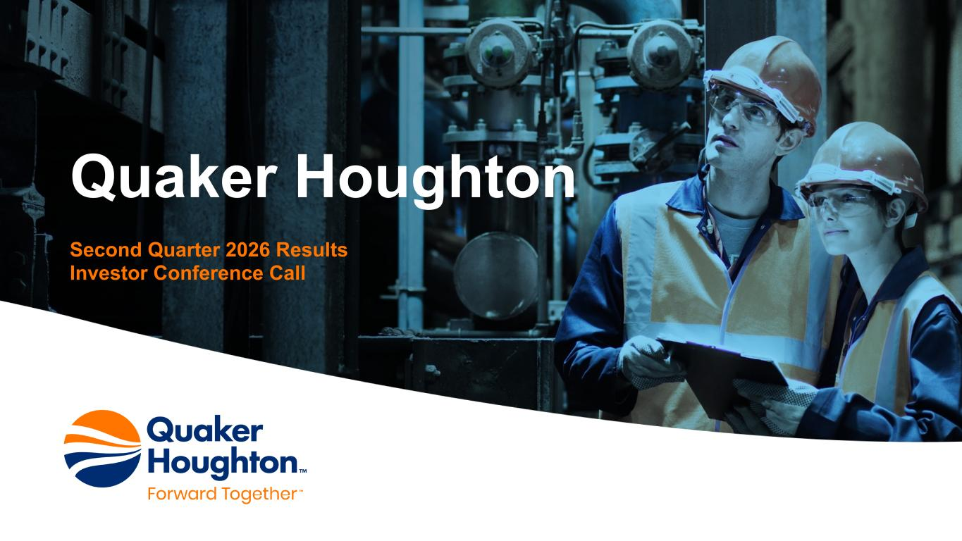
11
Quaker Houghton Second Quarter 2026 Results Investor Conference Call

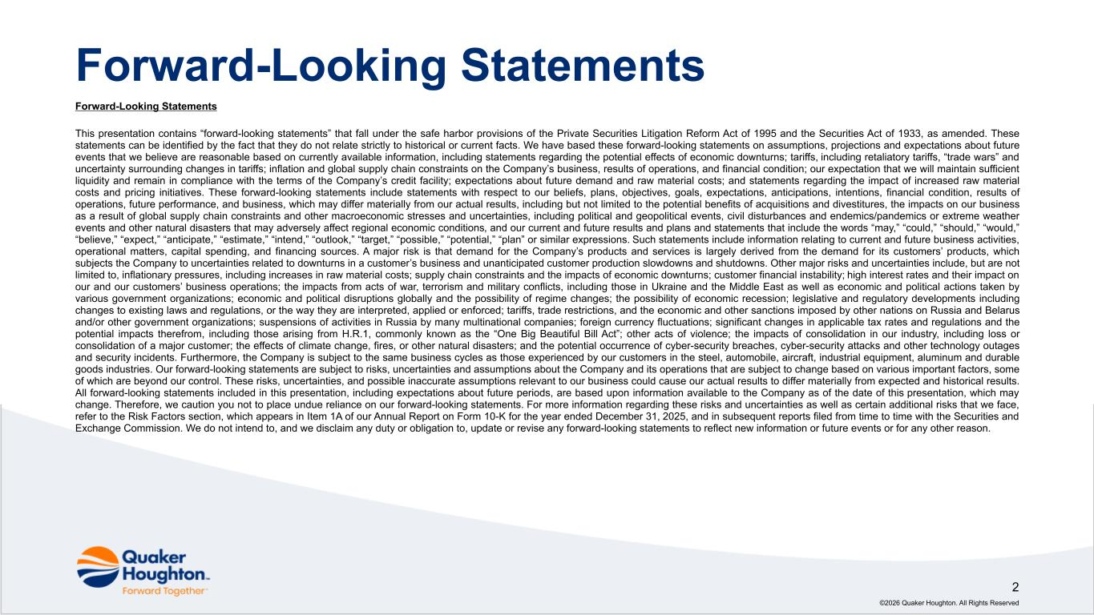
Forward-Looking Statements This presentation contains “forward-looking statements” that fall under the safe harbor provisions of the Private Securities Litigation Reform Act of 1995 and the Securities Act of 1933, as amended. These statements can be identified by the fact that they do not relate strictly to historical or current facts. We have based these forward-looking statements on assumptions, projections and expectations about future events that we believe are reasonable based on currently available information, including statements regarding the potential effects of economic downturns; tariffs, including retaliatory tariffs, “trade wars” and uncertainty surrounding changes in tariffs; inflation and global supply chain constraints on the Company’s business, results of operations, and financial condition; our expectation that we will maintain sufficient liquidity and remain in compliance with the terms of the Company’s credit facility; expectations about future demand and raw material costs; and statements regarding the impact of increased raw material costs and pricing initiatives. These forward-looking statements include statements with respect to our beliefs, plans, objectives, goals, expectations, anticipations, intentions, financial condition, results of operations, future performance, and business, which may differ materially from our actual results, including but not limited to the potential benefits of acquisitions and divestitures, the impacts on our business as a result of global supply chain constraints and other macroeconomic stresses and uncertainties, including political and geopolitical events, civil disturbances and endemics/pandemics or extreme weather events and other natural disasters that may adversely affect regional economic conditions, and our current and future results and plans and statements that include the words “may,” “could,” “should,” “would,” “believe,” “expect,” “anticipate,” “estimate,” “intend,” “outlook,” “target,” “possible,” “potential,” “plan” or similar expressions. Such statements include information relating to current and future business activities, operational matters, capital spending, and financing sources. A major risk is that demand for the Company’s products and services is largely derived from the demand for its customers’ products, which subjects the Company to uncertainties related to downturns in a customer’s business and unanticipated customer production slowdowns and shutdowns. Other major risks and uncertainties include, but are not limited to, inflationary pressures, including increases in raw material costs; supply chain constraints and the impacts of economic downturns; customer financial instability; high interest rates and their impact on our and our customers’ business operations; the impacts from acts of war, terrorism and military conflicts, including those in Ukraine and the Middle East as well as economic and political actions taken by various government organizations; economic and political disruptions globally and the possibility of regime changes; the possibility of economic recession; legislative and regulatory developments including changes to existing laws and regulations, or the way they are interpreted, applied or enforced; tariffs, trade restrictions, and the economic and other sanctions imposed by other nations on Russia and Belarus and/or other government organizations; suspensions of activities in Russia by many multinational companies; foreign currency fluctuations; significant changes in applicable tax rates and regulations and the potential impacts therefrom, including those arising from H.R.1, commonly known as the “One Big Beautiful Bill Act”; other acts of violence; the impacts of consolidation in our industry, including loss or consolidation of a major customer; the effects of climate change, fires, or other natural disasters; and the potential occurrence of cyber-security breaches, cyber-security attacks and other technology outages and security incidents. Furthermore, the Company is subject to the same business cycles as those experienced by our customers in the steel, automobile, aircraft, industrial equipment, aluminum and durable goods industries. Our forward-looking statements are subject to risks, uncertainties and assumptions about the Company and its operations that are subject to change based on various important factors, some of which are beyond our control. These risks, uncertainties, and possible inaccurate assumptions relevant to our business could cause our actual results to differ materially from expected and historical results. All forward-looking statements included in this presentation, including expectations about future periods, are based upon information available to the Company as of the date of this presentation, which may change. Therefore, we caution you not to place undue reliance on our forward-looking statements. For more information regarding these risks and uncertainties as well as certain additional risks that we face, refer to the Risk Factors section, which appears in Item 1A of our Annual Report on Form 10-K for the year ended December 31, 2025, and in subsequent reports filed from time to time with the Securities and Exchange Commission. We do not intend to, and we disclaim any duty or obligation to, update or revise any forward-looking statements to reflect new information or future events or for any other reason. ©2026 Quaker Houghton. All Rights Reserved 2 Forward-Looking Statements

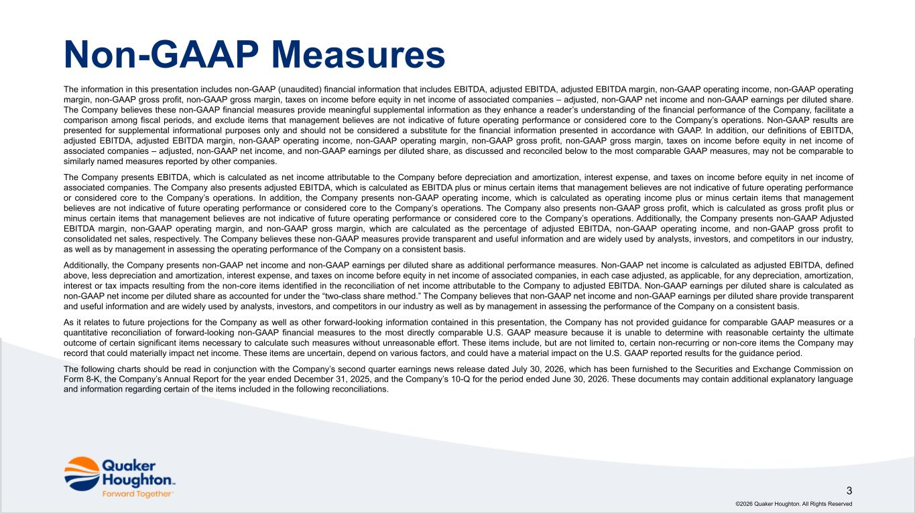
The information in this presentation includes non-GAAP (unaudited) financial information that includes EBITDA, adjusted EBITDA, adjusted EBITDA margin, non-GAAP operating income, non-GAAP operating margin, non-GAAP gross profit, non-GAAP gross margin, taxes on income before equity in net income of associated companies – adjusted, non-GAAP net income and non-GAAP earnings per diluted share. The Company believes these non-GAAP financial measures provide meaningful supplemental information as they enhance a reader’s understanding of the financial performance of the Company, facilitate a comparison among fiscal periods, and exclude items that management believes are not indicative of future operating performance or considered core to the Company’s operations. Non-GAAP results are presented for supplemental informational purposes only and should not be considered a substitute for the financial information presented in accordance with GAAP. In addition, our definitions of EBITDA, adjusted EBITDA, adjusted EBITDA margin, non-GAAP operating income, non-GAAP operating margin, non-GAAP gross profit, non-GAAP gross margin, taxes on income before equity in net income of associated companies – adjusted, non-GAAP net income, and non-GAAP earnings per diluted share, as discussed and reconciled below to the most comparable GAAP measures, may not be comparable to similarly named measures reported by other companies. The Company presents EBITDA, which is calculated as net income attributable to the Company before depreciation and amortization, interest expense, and taxes on income before equity in net income of associated companies. The Company also presents adjusted EBITDA, which is calculated as EBITDA plus or minus certain items that management believes are not indicative of future operating performance or considered core to the Company’s operations. In addition, the Company presents non-GAAP operating income, which is calculated as operating income plus or minus certain items that management believes are not indicative of future operating performance or considered core to the Company’s operations. The Company also presents non-GAAP gross profit, which is calculated as gross profit plus or minus certain items that management believes are not indicative of future operating performance or considered core to the Company’s operations. Additionally, the Company presents non-GAAP Adjusted EBITDA margin, non-GAAP operating margin, and non-GAAP gross margin, which are calculated as the percentage of adjusted EBITDA, non-GAAP operating income, and non-GAAP gross profit to consolidated net sales, respectively. The Company believes these non-GAAP measures provide transparent and useful information and are widely used by analysts, investors, and competitors in our industry, as well as by management in assessing the operating performance of the Company on a consistent basis. Additionally, the Company presents non-GAAP net income and non-GAAP earnings per diluted share as additional performance measures. Non-GAAP net income is calculated as adjusted EBITDA, defined above, less depreciation and amortization, interest expense, and taxes on income before equity in net income of associated companies, in each case adjusted, as applicable, for any depreciation, amortization, interest or tax impacts resulting from the non-core items identified in the reconciliation of net income attributable to the Company to adjusted EBITDA. Non-GAAP earnings per diluted share is calculated as non-GAAP net income per diluted share as accounted for under the “two-class share method.” The Company believes that non-GAAP net income and non-GAAP earnings per diluted share provide transparent and useful information and are widely used by analysts, investors, and competitors in our industry as well as by management in assessing the performance of the Company on a consistent basis. As it relates to future projections for the Company as well as other forward-looking information contained in this presentation, the Company has not provided guidance for comparable GAAP measures or a quantitative reconciliation of forward-looking non-GAAP financial measures to the most directly comparable U.S. GAAP measure because it is unable to determine with reasonable certainty the ultimate outcome of certain significant items necessary to calculate such measures without unreasonable effort. These items include, but are not limited to, certain non-recurring or non-core items the Company may record that could materially impact net income. These items are uncertain, depend on various factors, and could have a material impact on the U.S. GAAP reported results for the guidance period. The following charts should be read in conjunction with the Company’s second quarter earnings news release dated July 30, 2026, which has been furnished to the Securities and Exchange Commission on Form 8-K, the Company’s Annual Report for the year ended December 31, 2025, and the Company’s 10-Q for the period ended June 30, 2026. These documents may contain additional explanatory language and information regarding certain of the items included in the following reconciliations. ©2026 Quaker Houghton. All Rights Reserved 3 Non-GAAP Measures

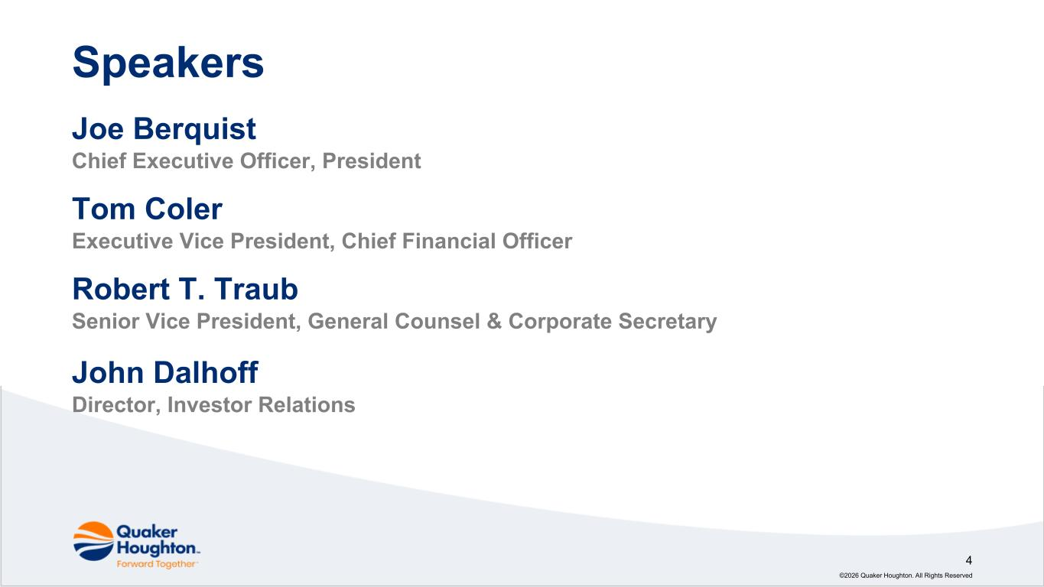
Joe Berquist Chief Executive Officer, President Tom Coler Executive Vice President, Chief Financial Officer Robert T. Traub Senior Vice President, General Counsel & Corporate Secretary John Dalhoff Director, Investor Relations ©2026 Quaker Houghton. All Rights Reserved 4 Speakers

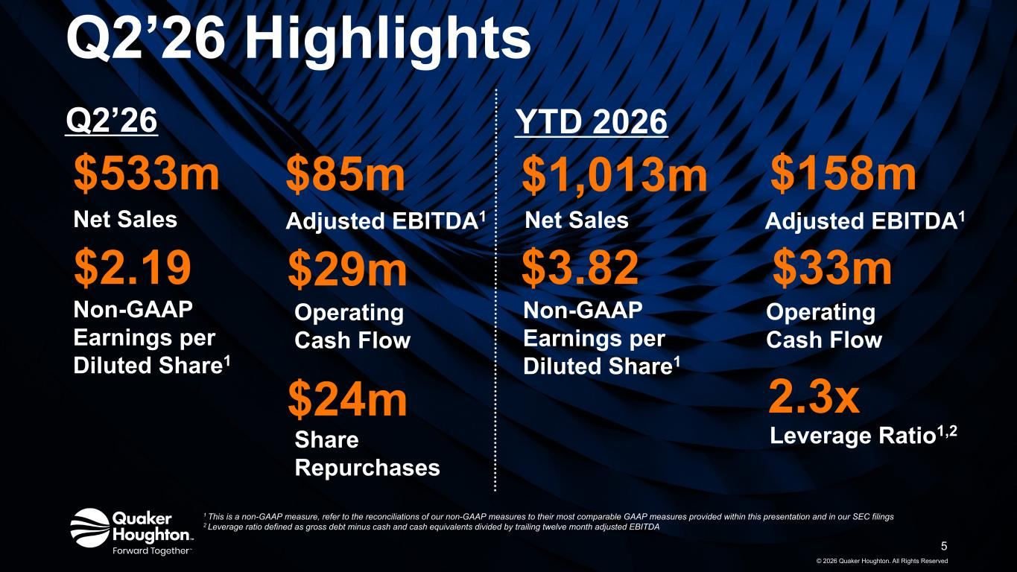
Q2’26 Highlights © 2026 Quaker Houghton. All Rights Reserved $533m Net Sales $158m Adjusted EBITDA1 5 $2.19 Non-GAAP Earnings per Diluted Share1 2.3x Leverage Ratio1,2 1 This is a non-GAAP measure, refer to the reconciliations of our non-GAAP measures to their most comparable GAAP measures provided within this presentation and in our SEC filings 2 Leverage ratio defined as gross debt minus cash and cash equivalents divided by trailing twelve month adjusted EBITDA $33m Operating Cash Flow Q2’26 YTD 2026 $1,013m Net Sales $3.82 Non-GAAP Earnings per Diluted Share1 Adjusted EBITDA1 $85m $29m Operating Cash Flow $24m Share Repurchases

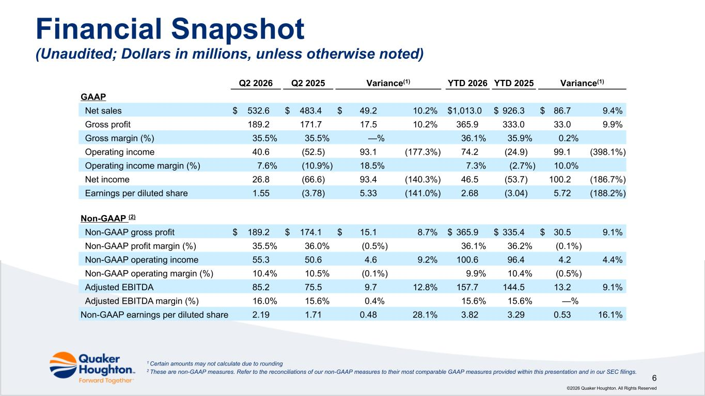
©2026 Quaker Houghton. All Rights Reserved 6 Financial Snapshot (Unaudited; Dollars in millions, unless otherwise noted) 1 Certain amounts may not calculate due to rounding 2 These are non-GAAP measures. Refer to the reconciliations of our non-GAAP measures to their most comparable GAAP measures provided within this presentation and in our SEC filings. Q2 2026 Q2 2025 Variance(1) YTD 2026 YTD 2025 Variance(1) GAAP Net sales $ 532.6 $ 483.4 $ 49.2 10.2% $ 1,013.0 $ 926.3 $ 86.7 9.4% Gross profit 189.2 171.7 17.5 10.2% 365.9 333.0 33.0 9.9% Gross margin (%) 35.5% 35.5% —% 36.1% 35.9% 0.2% Operating income 40.6 (52.5) 93.1 (177.3%) 74.2 (24.9) 99.1 (398.1%) Operating income margin (%) 7.6% (10.9%) 18.5% 7.3% (2.7%) 10.0% Net income 26.8 (66.6) 93.4 (140.3%) 46.5 (53.7) 100.2 (186.7%) Earnings per diluted share 1.55 (3.78) 5.33 (141.0%) 2.68 (3.04) 5.72 (188.2%) Non-GAAP (2) Non-GAAP gross profit $ 189.2 $ 174.1 $ 15.1 8.7% $ 365.9 $ 335.4 $ 30.5 9.1% Non-GAAP profit margin (%) 35.5% 36.0% (0.5%) 36.1% 36.2% (0.1%) Non-GAAP operating income 55.3 50.6 4.6 9.2% 100.6 96.4 4.2 4.4% Non-GAAP operating margin (%) 10.4% 10.5% (0.1%) 9.9% 10.4% (0.5%) Adjusted EBITDA 85.2 75.5 9.7 12.8% 157.7 144.5 13.2 9.1% Adjusted EBITDA margin (%) 16.0% 15.6% 0.4% 15.6% 15.6% —% Non-GAAP earnings per diluted share 2.19 1.71 0.48 28.1% 3.82 3.29 0.53 16.1%

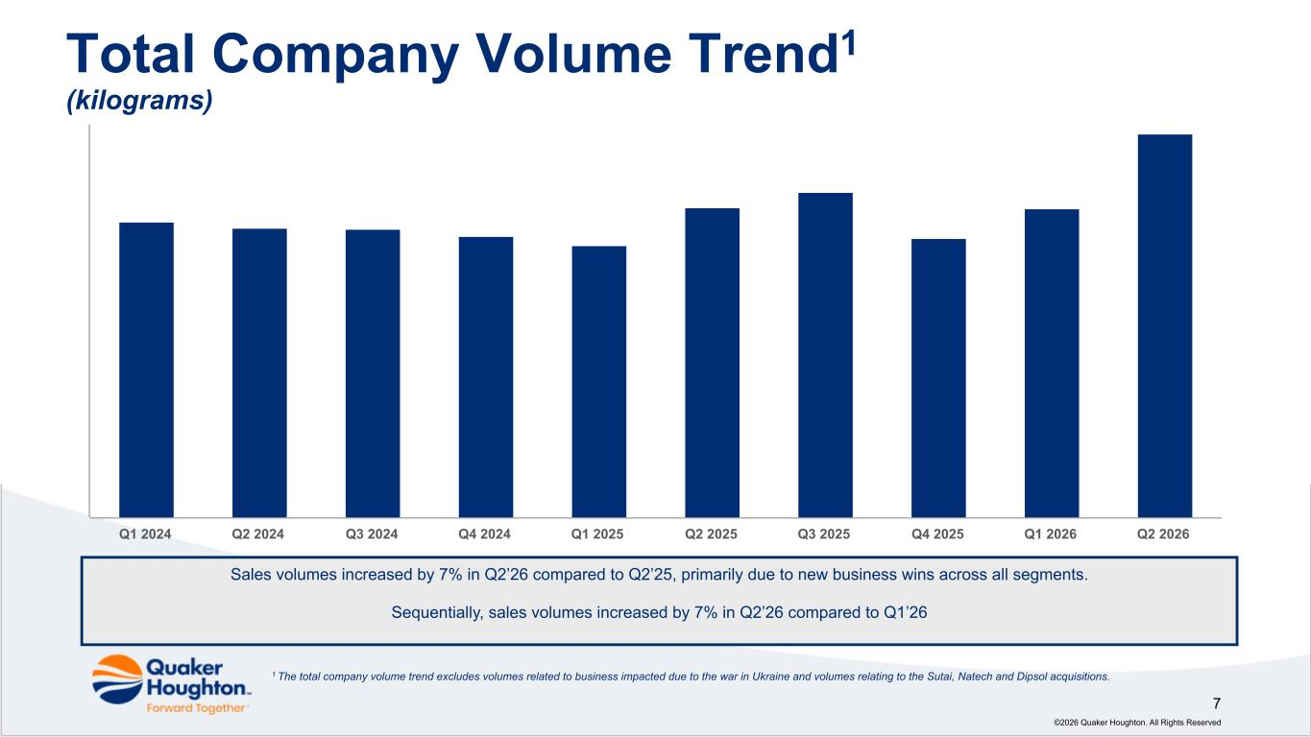
Sales volumes increased by 7% in Q2’26 compared to Q2’25, primarily due to new business wins across all segments. Sequentially, sales volumes increased by 7% in Q2’26 compared to Q1’26 Total Company Volume Trend1 (kilograms) 7 ©2026 Quaker Houghton. All Rights Reserved Q1 2024 Q2 2024 Q3 2024 Q4 2024 Q1 2025 Q2 2025 Q3 2025 Q4 2025 Q1 2026 Q2 2026 1 The total company volume trend excludes volumes related to business impacted due to the war in Ukraine and volumes relating to the Sutai, Natech and Dipsol acquisitions.

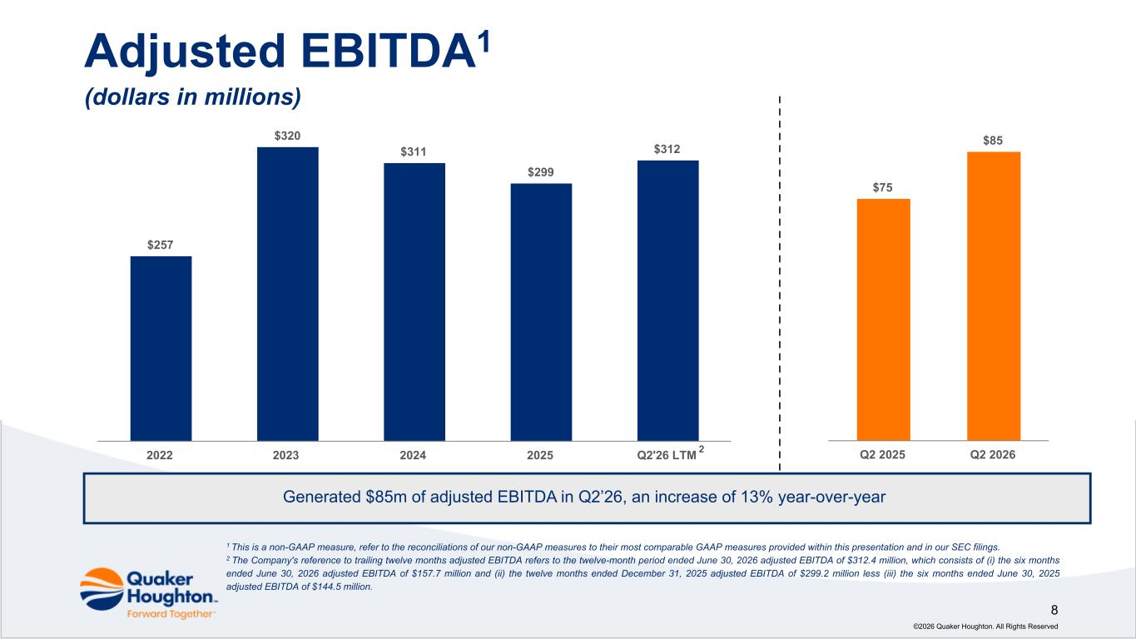
©2026 Quaker Houghton. All Rights Reserved 8 Adjusted EBITDA1 (dollars in millions) Generated $85m of adjusted EBITDA in Q2’26, an increase of 13% year-over-year 1 This is a non-GAAP measure, refer to the reconciliations of our non-GAAP measures to their most comparable GAAP measures provided within this presentation and in our SEC filings. 2 The Company's reference to trailing twelve months adjusted EBITDA refers to the twelve-month period ended June 30, 2026 adjusted EBITDA of $312.4 million, which consists of (i) the six months ended June 30, 2026 adjusted EBITDA of $157.7 million and (ii) the twelve months ended December 31, 2025 adjusted EBITDA of $299.2 million less (iii) the six months ended June 30, 2025 adjusted EBITDA of $144.5 million. $257 $320 $311 $299 $312 2022 2023 2024 2025 Q2'26 LTM $75 $85 Q2 2025 Q2 20262

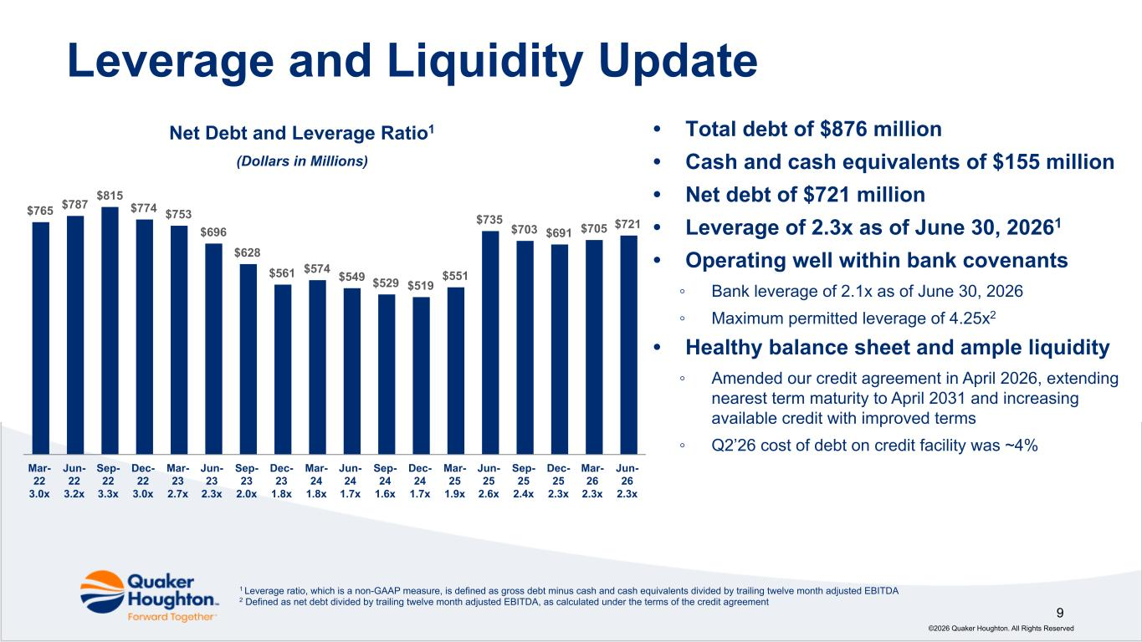
Leverage and Liquidity Update 9 ©2026 Quaker Houghton. All Rights Reserved 1 Leverage ratio, which is a non-GAAP measure, is defined as gross debt minus cash and cash equivalents divided by trailing twelve month adjusted EBITDA 2 Defined as net debt divided by trailing twelve month adjusted EBITDA, as calculated under the terms of the credit agreement $765 $787 $815 $774 $753 $696 $628 $561 $574 $549 $529 $519 $551 $735 $703 $691 $705 $721 Mar- 22 3.0x Jun- 22 3.2x Sep- 22 3.3x Dec- 22 3.0x Mar- 23 2.7x Jun- 23 2.3x Sep- 23 2.0x Dec- 23 1.8x Mar- 24 1.8x Jun- 24 1.7x Sep- 24 1.6x Dec- 24 1.7x Mar- 25 1.9x Jun- 25 2.6x Sep- 25 2.4x Dec- 25 2.3x Mar- 26 2.3x Jun- 26 2.3x Net Debt and Leverage Ratio1 (Dollars in Millions) • Total debt of $876 million • Cash and cash equivalents of $155 million • Net debt of $721 million • Leverage of 2.3x as of June 30, 20261 • Operating well within bank covenants ◦ Bank leverage of 2.1x as of June 30, 2026 ◦ Maximum permitted leverage of 4.25x2 • Healthy balance sheet and ample liquidity ◦ Amended our credit agreement in April 2026, extending nearest term maturity to April 2031 and increasing available credit with improved terms ◦ Q2’26 cost of debt on credit facility was ~4%

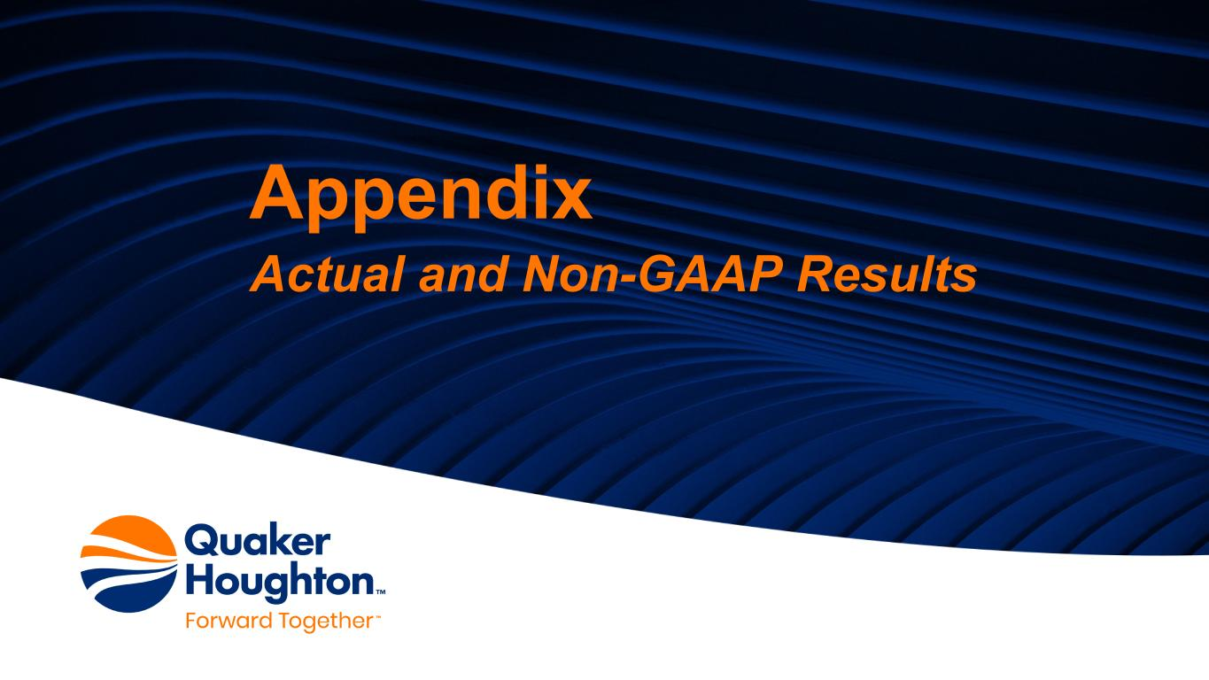
Appendix Actual and Non-GAAP Results

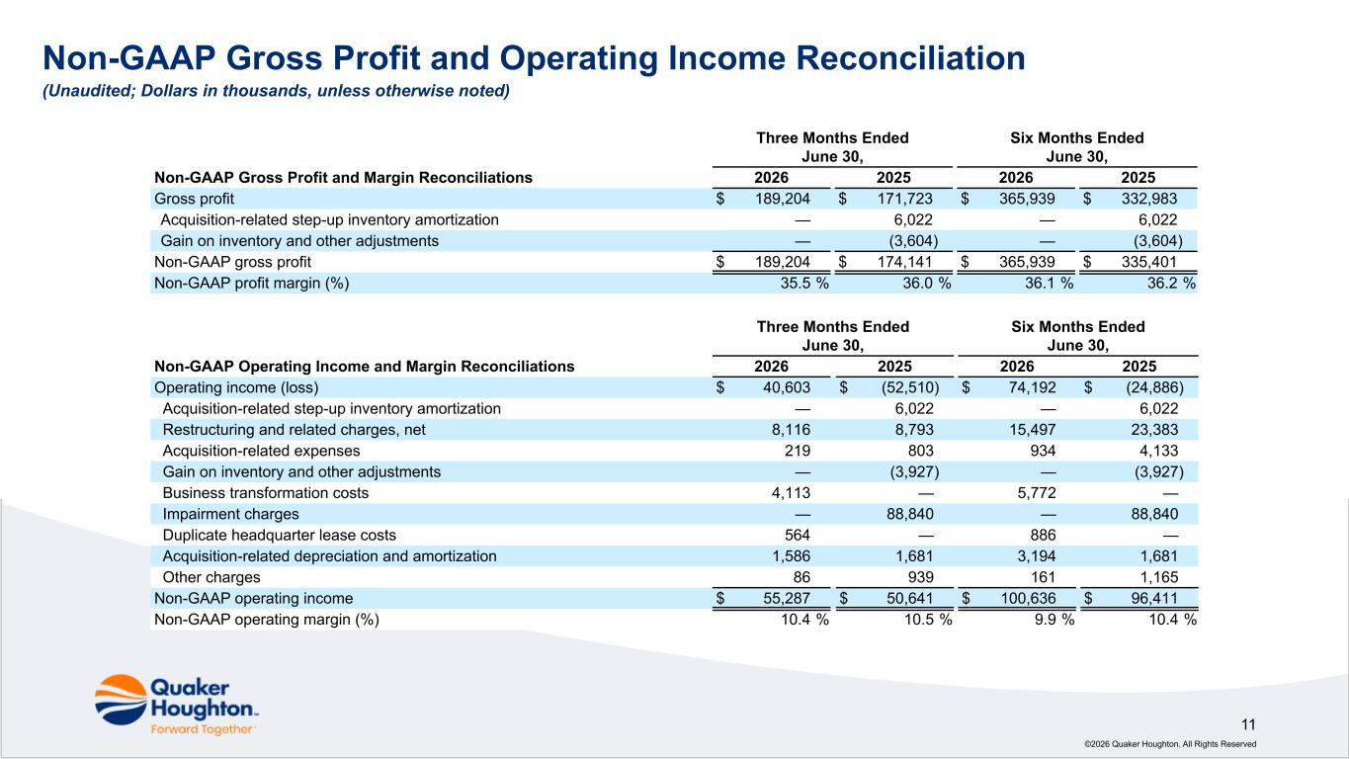
©2026 Quaker Houghton. All Rights Reserved 11 Non-GAAP Gross Profit and Operating Income Reconciliation (Unaudited; Dollars in thousands, unless otherwise noted) Three Months Ended June 30, Six Months Ended June 30, Non-GAAP Operating Income and Margin Reconciliations 2026 2025 2026 2025 Operating income (loss) $ 40,603 $ (52,510) $ 74,192 $ (24,886) Acquisition-related step-up inventory amortization — 6,022 — 6,022 Restructuring and related charges, net 8,116 8,793 15,497 23,383 Acquisition-related expenses 219 803 934 4,133 Gain on inventory and other adjustments — (3,927) — (3,927) Business transformation costs 4,113 — 5,772 — Impairment charges — 88,840 — 88,840 Duplicate headquarter lease costs 564 — 886 — Acquisition-related depreciation and amortization 1,586 1,681 3,194 1,681 Other charges 86 939 161 1,165 Non-GAAP operating income $ 55,287 $ 50,641 $ 100,636 $ 96,411 Non-GAAP operating margin (%) 10.4 % 10.5 % 9.9 % 10.4 % Three Months Ended June 30, Six Months Ended June 30, Non-GAAP Gross Profit and Margin Reconciliations 2026 2025 2026 2025 Gross profit $ 189,204 $ 171,723 $ 365,939 $ 332,983 Acquisition-related step-up inventory amortization — 6,022 — 6,022 Gain on inventory and other adjustments — (3,604) — (3,604) Non-GAAP gross profit $ 189,204 $ 174,141 $ 365,939 $ 335,401 Non-GAAP profit margin (%) 35.5 % 36.0 % 36.1 % 36.2 %

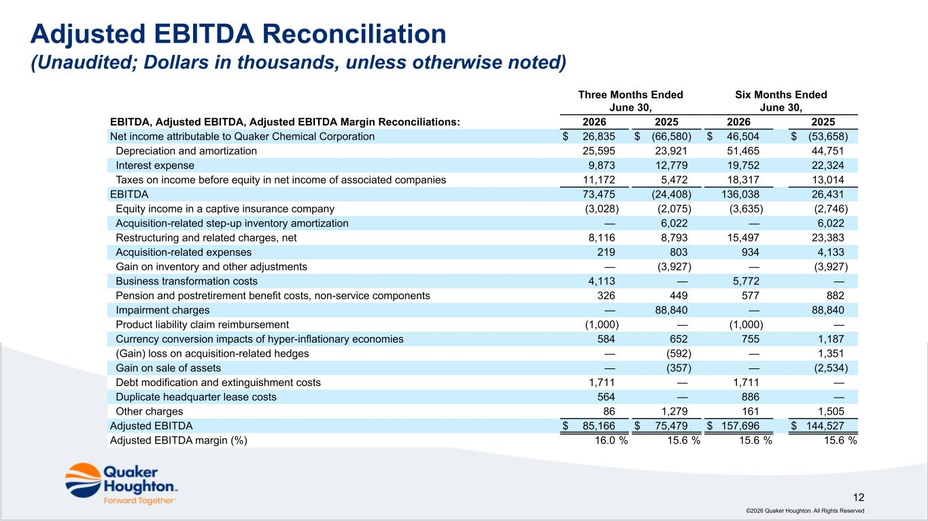
©2026 Quaker Houghton. All Rights Reserved 12 Adjusted EBITDA Reconciliation (Unaudited; Dollars in thousands, unless otherwise noted) EBITDA, Adjusted EBITDA, Adjusted EBITDA Margin Reconciliations: Three Months Ended June 30, Six Months Ended June 30, 2026 2025 2026 2025 Net income attributable to Quaker Chemical Corporation $ 26,835 $ (66,580) $ 46,504 $ (53,658) Depreciation and amortization 25,595 23,921 51,465 44,751 Interest expense 9,873 12,779 19,752 22,324 Taxes on income before equity in net income of associated companies 11,172 5,472 18,317 13,014 EBITDA 73,475 (24,408) 136,038 26,431 Equity income in a captive insurance company (3,028) (2,075) (3,635) (2,746) Acquisition-related step-up inventory amortization — 6,022 — 6,022 Restructuring and related charges, net 8,116 8,793 15,497 23,383 Acquisition-related expenses 219 803 934 4,133 Gain on inventory and other adjustments — (3,927) — (3,927) Business transformation costs 4,113 — 5,772 — Pension and postretirement benefit costs, non-service components 326 449 577 882 Impairment charges — 88,840 — 88,840 Product liability claim reimbursement (1,000) — (1,000) — Currency conversion impacts of hyper-inflationary economies 584 652 755 1,187 (Gain) loss on acquisition-related hedges — (592) — 1,351 Gain on sale of assets — (357) — (2,534) Debt modification and extinguishment costs 1,711 — 1,711 — Duplicate headquarter lease costs 564 — 886 — Other charges 86 1,279 161 1,505 Adjusted EBITDA $ 85,166 $ 75,479 $ 157,696 $ 144,527 Adjusted EBITDA margin (%) 16.0 % 15.6 % 15.6 % 15.6 %

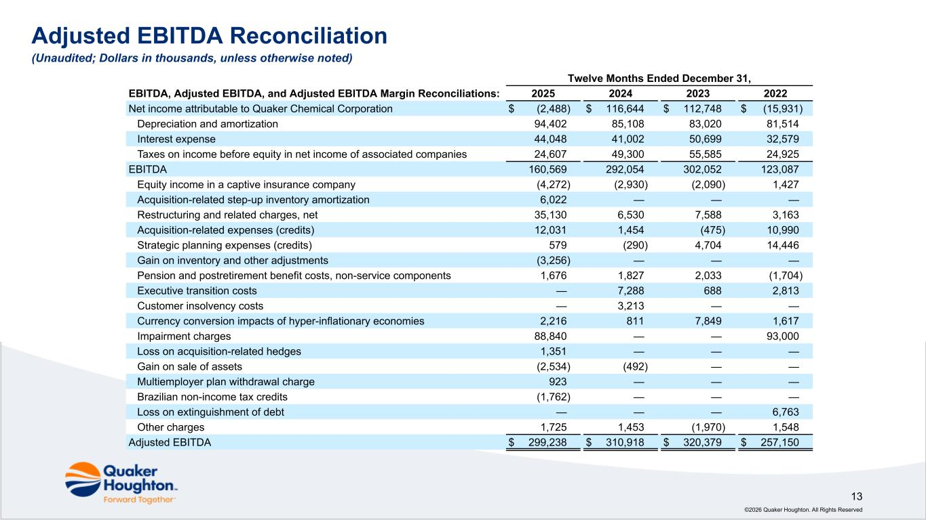
©2026 Quaker Houghton. All Rights Reserved 13 EBITDA, Adjusted EBITDA, and Adjusted EBITDA Margin Reconciliations: Twelve Months Ended December 31, 2025 2024 2023 2022 Net income attributable to Quaker Chemical Corporation $ (2,488) $ 116,644 $ 112,748 $ (15,931) Depreciation and amortization 94,402 85,108 83,020 81,514 Interest expense 44,048 41,002 50,699 32,579 Taxes on income before equity in net income of associated companies 24,607 49,300 55,585 24,925 EBITDA 160,569 292,054 302,052 123,087 Equity income in a captive insurance company (4,272) (2,930) (2,090) 1,427 Acquisition-related step-up inventory amortization 6,022 — — — Restructuring and related charges, net 35,130 6,530 7,588 3,163 Acquisition-related expenses (credits) 12,031 1,454 (475) 10,990 Strategic planning expenses (credits) 579 (290) 4,704 14,446 Gain on inventory and other adjustments (3,256) — — — Pension and postretirement benefit costs, non-service components 1,676 1,827 2,033 (1,704) Executive transition costs — 7,288 688 2,813 Customer insolvency costs — 3,213 — — Currency conversion impacts of hyper-inflationary economies 2,216 811 7,849 1,617 Impairment charges 88,840 — — 93,000 Loss on acquisition-related hedges 1,351 — — — Gain on sale of assets (2,534) (492) — — Multiemployer plan withdrawal charge 923 — — — Brazilian non-income tax credits (1,762) — — — Loss on extinguishment of debt — — — 6,763 Other charges 1,725 1,453 (1,970) 1,548 Adjusted EBITDA $ 299,238 $ 310,918 $ 320,379 $ 257,150 Adjusted EBITDA Reconciliation (Unaudited; Dollars in thousands, unless otherwise noted)

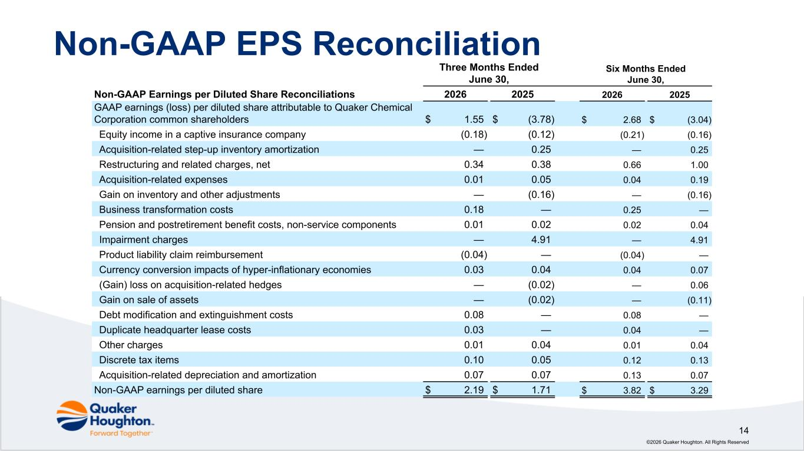
©2026 Quaker Houghton. All Rights Reserved 14 Non-GAAP EPS Reconciliation Three Months Ended June 30, Six Months Ended June 30, Non-GAAP Earnings per Diluted Share Reconciliations 2026 2025 2026 2025 GAAP earnings (loss) per diluted share attributable to Quaker Chemical Corporation common shareholders $ 1.55 $ (3.78) $ 2.68 $ (3.04) Equity income in a captive insurance company (0.18) (0.12) (0.21) (0.16) Acquisition-related step-up inventory amortization — 0.25 — 0.25 Restructuring and related charges, net 0.34 0.38 0.66 1.00 Acquisition-related expenses 0.01 0.05 0.04 0.19 Gain on inventory and other adjustments — (0.16) — (0.16) Business transformation costs 0.18 — 0.25 — Pension and postretirement benefit costs, non-service components 0.01 0.02 0.02 0.04 Impairment charges — 4.91 — 4.91 Product liability claim reimbursement (0.04) — (0.04) — Currency conversion impacts of hyper-inflationary economies 0.03 0.04 0.04 0.07 (Gain) loss on acquisition-related hedges — (0.02) — 0.06 Gain on sale of assets — (0.02) — (0.11) Debt modification and extinguishment costs 0.08 — 0.08 — Duplicate headquarter lease costs 0.03 — 0.04 — Other charges 0.01 0.04 0.01 0.04 Discrete tax items 0.10 0.05 0.12 0.13 Acquisition-related depreciation and amortization 0.07 0.07 0.13 0.07 Non-GAAP earnings per diluted share $ 2.19 $ 1.71 $ 3.82 $ 3.29

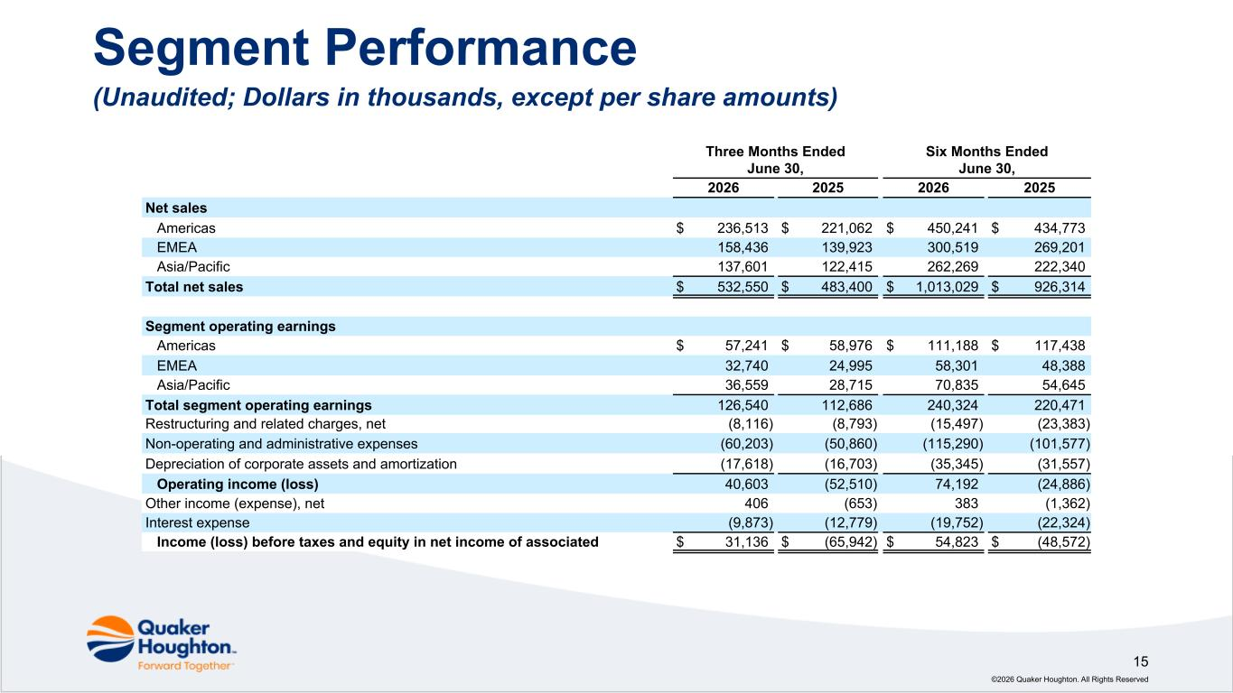
©2026 Quaker Houghton. All Rights Reserved 15 Segment Performance (Unaudited; Dollars in thousands, except per share amounts) Three Months Ended June 30, Six Months Ended June 30, 2026 2025 2026 2025 Net sales Americas $ 236,513 $ 221,062 $ 450,241 $ 434,773 EMEA 158,436 139,923 300,519 269,201 Asia/Pacific 137,601 122,415 262,269 222,340 Total net sales $ 532,550 $ 483,400 $ 1,013,029 $ 926,314 Segment operating earnings Americas $ 57,241 $ 58,976 $ 111,188 $ 117,438 EMEA 32,740 24,995 58,301 48,388 Asia/Pacific 36,559 28,715 70,835 54,645 Total segment operating earnings 126,540 112,686 240,324 220,471 Restructuring and related charges, net (8,116) (8,793) (15,497) (23,383) Non-operating and administrative expenses (60,203) (50,860) (115,290) (101,577) Depreciation of corporate assets and amortization (17,618) (16,703) (35,345) (31,557) Operating income (loss) 40,603 (52,510) 74,192 (24,886) Other income (expense), net 406 (653) 383 (1,362) Interest expense (9,873) (12,779) (19,752) (22,324) Income (loss) before taxes and equity in net income of associated $ 31,136 $ (65,942) $ 54,823 $ (48,572)

